|  |  |  |
| --- | --- | --- |
| **CL-1002 Programming Fundamentals** | **LAB - 06**  **Nested Decision Structure & Ternary Operators** | |
| **NATIONAL UNIVERSITY OF COMPUTER AND EMERGING SCIENCES**  **Fall 2022**  **NATIONAL UNIVERSITY OF COMPUTER AND EMERGING SCIENCES**  **NATIONAL UNIVERSITY OF COMPUTER AND EMERGING SCIENCES**  **NATIONAL UNIVERSITY OF COMPUTER AND EMERGING SCIENCES** | |  |

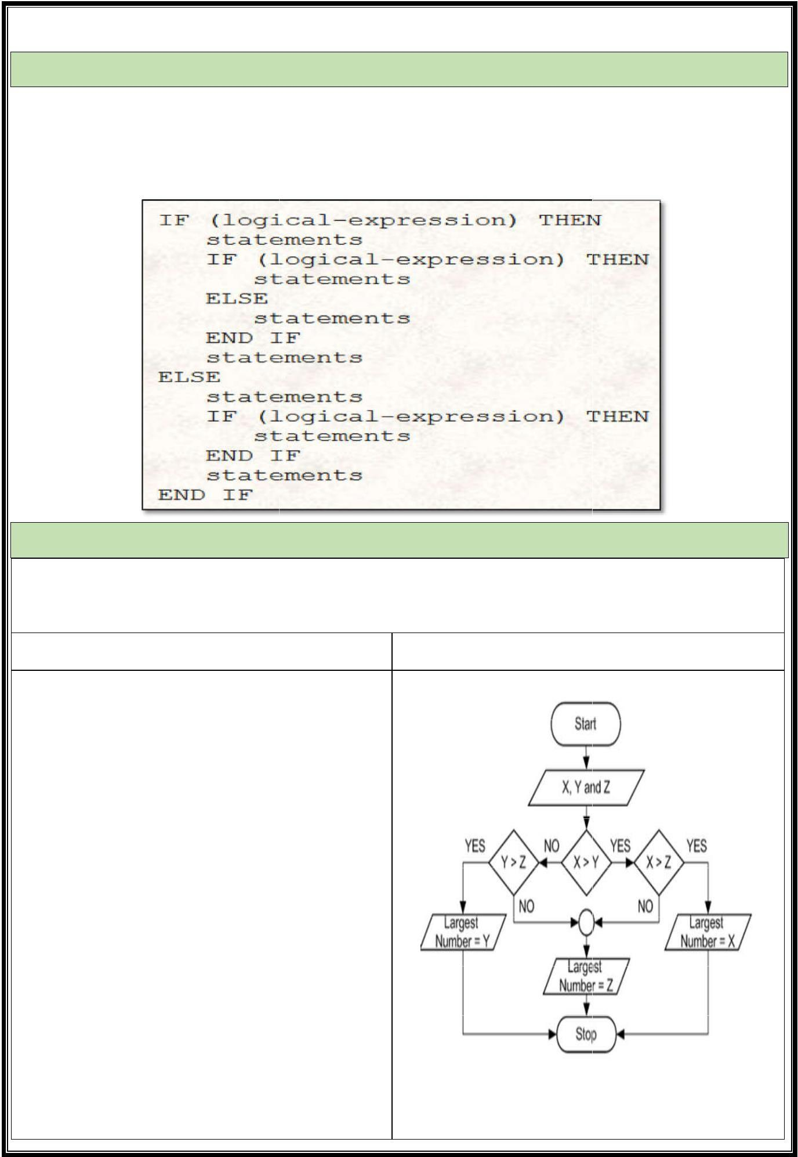

**Nested If-else Statement**

Placing the block of if else statement inside an existing if or else block statement is called nested If else statement. Each block of nested if else, logically perform same as simple if else statements. Whenever a user wants to check more than one condition at a time, the appropriate way is to use nested if-else statements. Following is the structure of nested if else statement.

**Example Nested If-else statement**

**Problem**

**From the given three values, find the largest value. Algorithm Flowchart**

1. **Step 1: Input X, Y,Z**
2. **Step 2: if(X>Y) then**
3. **If(X>Z) then**
4. **Max= X [X>Y, X>Z]**
5. **Else**
6. **Max= Z [Z>X>Y]**
7. **Endif**
8. **Else**
9. **If(Y>Z) then**
10. **Max = Y [Y>X, Y>Z]]**
11. **Else**
12. **Max = Z [Z>Y>X]**
13. **Endif**
14. **Endif**
15. **Step 3: Print “The largest number is”, Max**

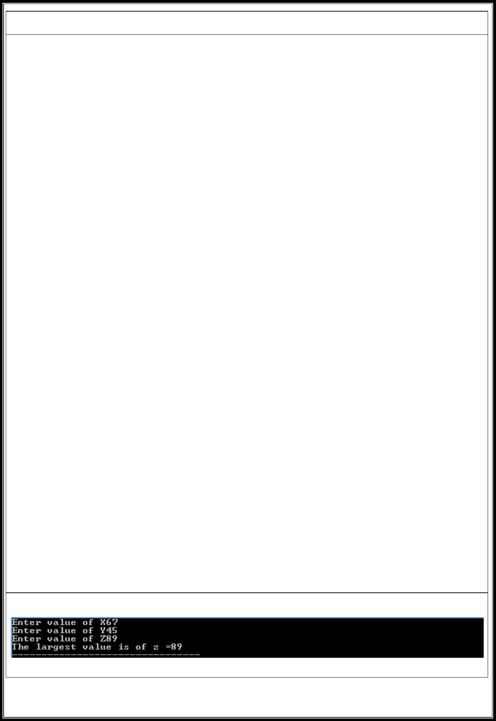

**C-Implementation**

#include<stdio.h> main(){

Int x,y,z;

printf("Enter value of X"); scanf("%d",&x); printf("Enter value of Y"); scanf("%d",&y); printf("Enter value of Z"); scanf("%d",&z);

if(x>y){

if(x>z){

printf("The largest value is of x = %d",x);

}

else{

printf("The largest value is of z =%d", z);

}

}

else{

if(y>z){

printf("The largest value is of y= %d",y);

}

else{

printf("The largest value is of z= %d",z);

}

}

}

Output

**Nested Switch-Case Statement**

Placing the simple switch case statements inside an existing case statement is called nested switch-case statement. Each block of nested switch case statement logically performs the same as simple switch case statement. Following is the syntax of nested switch case statement.

**Switch(controlling expression){ Label set 1:**

**Statement 1; Break;**

**Label set 2:**

**Statement 2; Switch(controlling expression){ Label set 1:**

**Statement 1; Break;**

**Label set 2:**

**Statement 2; Break;**

**Default:**

**Statement d;**

**}**

**Break;**

**Default:**

**Statement d;**

**}**

**Example Nested switch-case statement**

**Problem**

**Ayesha is interested in knowing the names of different countries. She wants a list of countries by just giving a starting and ending letter.**

**C-Implementation**



#include <stdio.h>

main()

{

char start,e;

printf("Please say starting letter of country");

scanf("%c",&start);

switch(start)

{

case 'A':

case 'a':

printf("Please say ending letter\n");

scanf("\n%c",&e);

switch(e)

{

case 'A':

case 'a':

printf("\n Alaska \n Albania \n Algeria");

break;

default:

printf("\n No such country");

}

break; case 'B':

case 'b':

printf("Please say ending letter\n"); scanf("\n%c",&e);

switch(e)

{

case 'A':

case 'a':

printf("\n Bulgeria \n Bolivia \n Botswana"); break;

default:

printf(" No such country");

}

break; default:

printf("Please type correct letter");

}

}

Output:

**Ternary Operator (?:) in C**

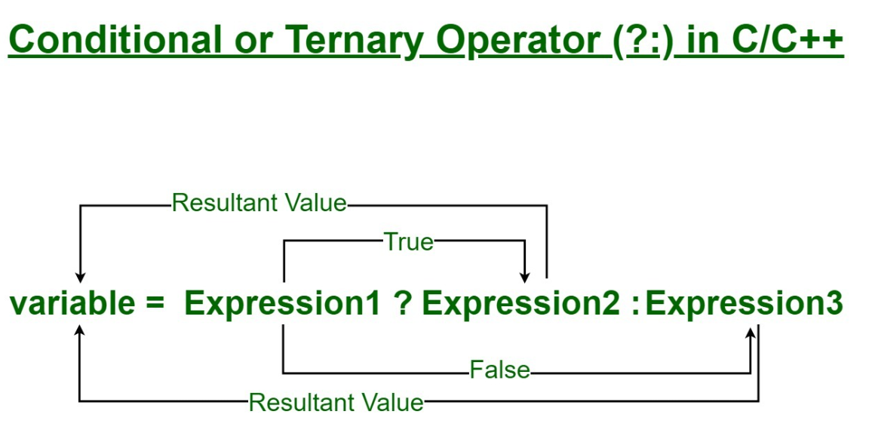

Syntax:

The conditional operator is of the form

variable = Expression1 ? Expression2 : Expression3

Or the syntax will also be in this form

variable = (condition) ? Expression2 : Expression3

Or syntax will also be in this form

(condition) ? (variable = Expression2) : (variable = Expression3)

It can be visualized into if-else statement as:

if(Expression1)

{

variable = Expression2;

}

else

{

variable = Expression3;

}

The conditional operator is kind of like the if-else statement as it does follow the same algorithm as of if-else statement, but the conditional operator takes less space and helps to write the if-else statements in the shortest way possible.

Example:

Output:

Example 2:

Output:

Nesting of these operators can also be done as

x = 2 > 5 != 1 ? 5 < 8 && 8 > 2 ? !5 ? 10 : 20 : 30 : 40;

***EXERCISES***

Task1:

Write a program that asks for the number of calories and fat grams in a food.  The program should display the percentage of calories that come from fat

One gram of fat has 9 calories, so Calories from fat = fat grams * 9

The percentage of calories from fat can be calculated as: calories from fat/total calories

Input validation: Make sure the number of calories and fat grams are not less than 0.

Also, the number of calories from fat cannot be greater than the total number of calories.  If that happens, display an error message indicating that either the calories or fat grams were incorrectly entered.

Task2:

The weekday is true if it is a weekday, and the vacation is true if we are on vacation. We sleep in if it is not a weekday or we're on vacation. Print true if we sleep in.

sleepIn(false, false) → true  
sleepIn(true, false) → false  
sleepIn(false, true) → true

Task3:

Write a program to control a coffee machine. Allow the user to input the type of coffee as B for Black and W for White. Ask the user if the cup size is double and if the coffee is manual. The following table details the time chart for the machine for each coffee type. Display a statement for each step. If the coffee size is double, increase the baking time by 50 percent. Use functions to display instructions to the user and to compute the coffee time.

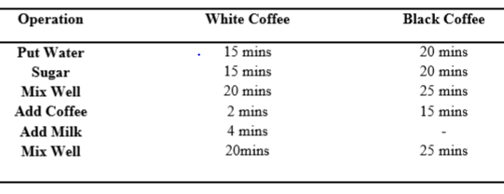

**Note: Use switch structure to solve this problem.**

Task4:

Using IF and Switch statement, write a program that displays the following menu for the food items available to take order from the customer:

|  |  |  |
| --- | --- | --- |
| ∙ | B= Burger | 200 |
| ∙ | F= French Fries | 50 |
| ∙ | P= Pizza | 500 |
| ∙ | S= Sandwiches | 150 |

The costumer can order any combination of available food. The program first asks to enter the no of types of snacks either a single snack or combination of two then it ask to enter the choice i.e. B for Burger and then for quantity. The program should finally display the total charges for the order.Text

Task5:

Write C Program to Check Whether a Number is Positive or Negative and check if the number is even or odd. Do this with Ternary operators.

E.g., Input =4

Output: Number 4 is positive

Number 4 is also Even

Task6:

Write a nested if statement for the decision diagrammed in the accompanying flowchart. Use a multiple-alternative if statements for intermediate decisions where possible.

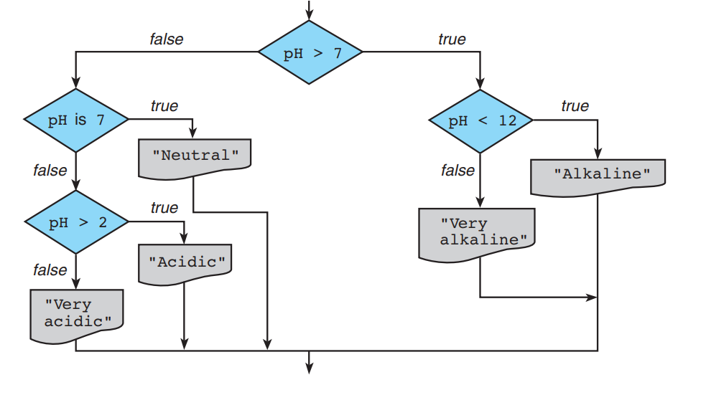

Task7:

Implement the following decision table using a nested if statement. Assume that the grade point average is within the range 0.0 through 4.0.

Task8:

#include <stdio.h>

**int** main()

{

**int** x;

    x = 5 > 8 ? 10 : 1 != 2 < 5 ? 20 : 30;

**printf**("Value of x:%d", x);

**return** 0;

}

Explain why the output is 30

Task9:

Using Ternary operators write a C-Program that can identify if the last digit of the number is zero or non-zero. If its zero, the program should print “Last Digit is zero” if it’s non-zero the program should print “Last Digit non-zero”

Example:  
Input 5; Output: Last Digit Non-Zero

Input 20; Output: Last Digit Zero